Exercise: Development Workflow
Exercises for the DevOps for Developers module @ SoftUni

Scary Story
Your task is to follow the entire process of development workflow.
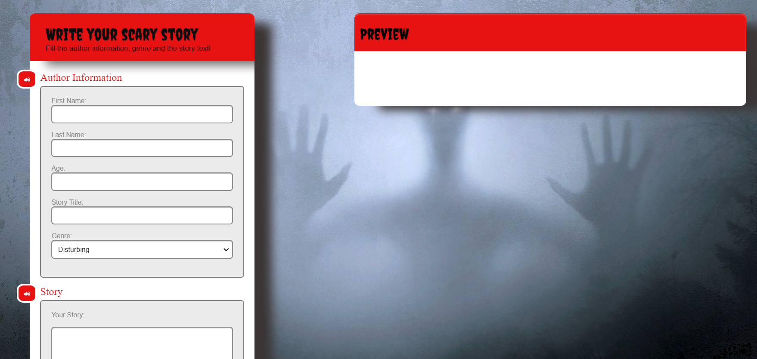
You should have a GitHub Projects board with following categories:
- Pending
- Sprint TODO
- In Progress
- For Testing
- Verified
- For Deploy
- Done
GitHub Projects visualizes the issues (tasks) workflow as a Kanban board.
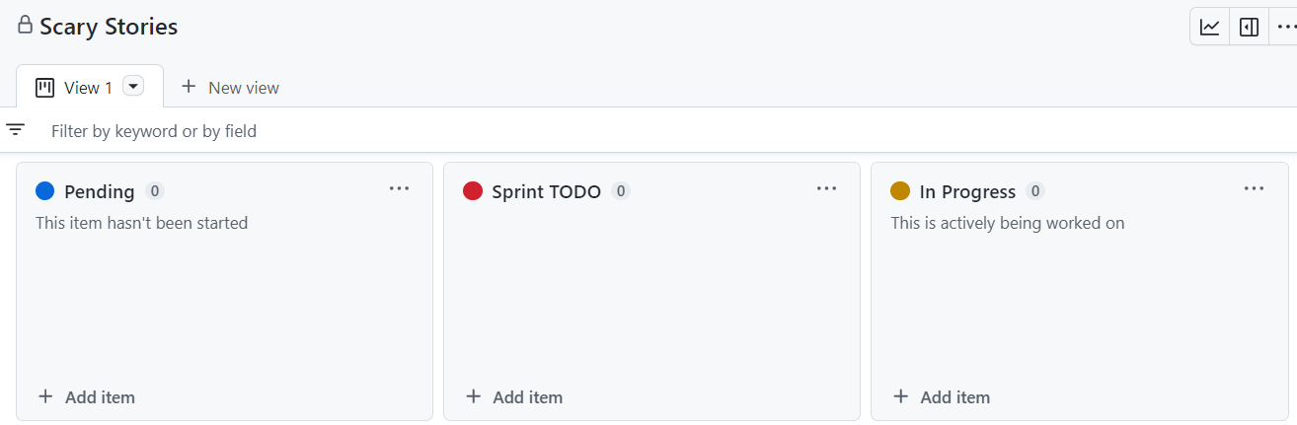
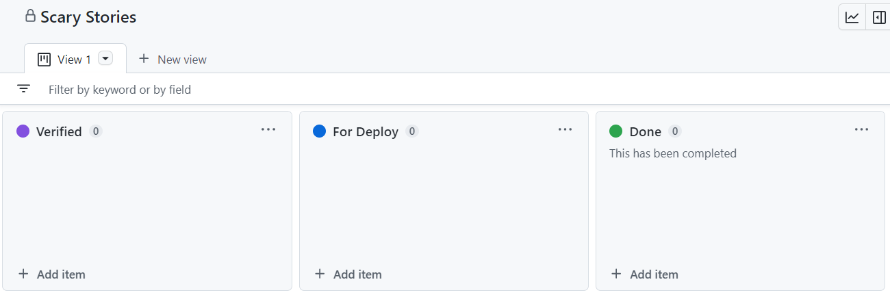
You should create three issues:
- Change background
- Add genre field
- Add field icons
NOTE: You can work in in teams of 3 students or work alone with several roles to simulate multi-user interaction, where each role follows the provided instructions for the given team member.

Senior
- Make an empty GitHub repo and commit files from resources.
- Create a GitHub Projects board and add tasks.
- Deploy site from the staging branch to the staging environment on Render.com.
- Conduct a code review when a pull request is created to the staging branch
- At the end, merge the staging to the main branch
- Deploy site from the main branch to the production environment on Render.com

QA
- Deploy site from the qa branch to the QA environment on Render.com (first time, then it will be automated)
- Looks QA environment to see if changes are done correctly
- If something does not pass, return the issue to "In Progress"

Junior
- Create a branch for each issue.
- Implement the issue TODOs.
- When ready, merge each of your feature branches to the qa branch
- Then, if issue is "Verified", merge its feature branch to the staging branch with a pull request

Senior

Step 1: Creating an Empty GitHub Repository
Senior makes an empty GitHub repo and commits files from resources. After that they add the Junior and the QA as collaborators.
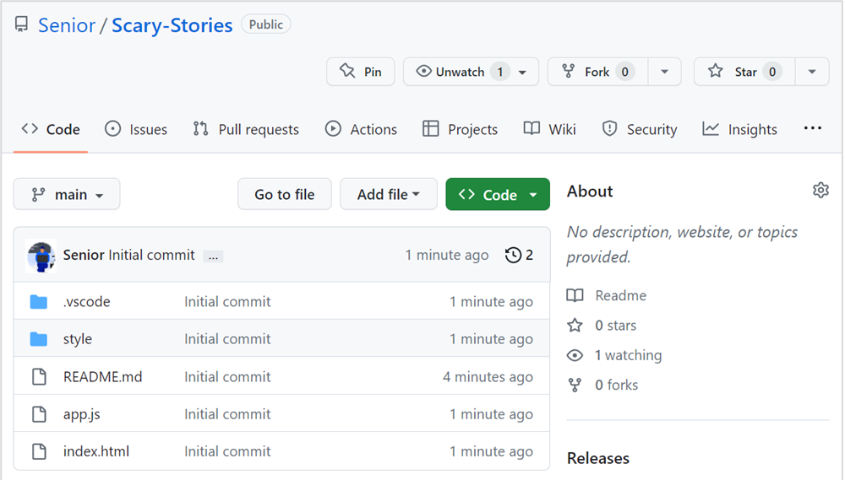
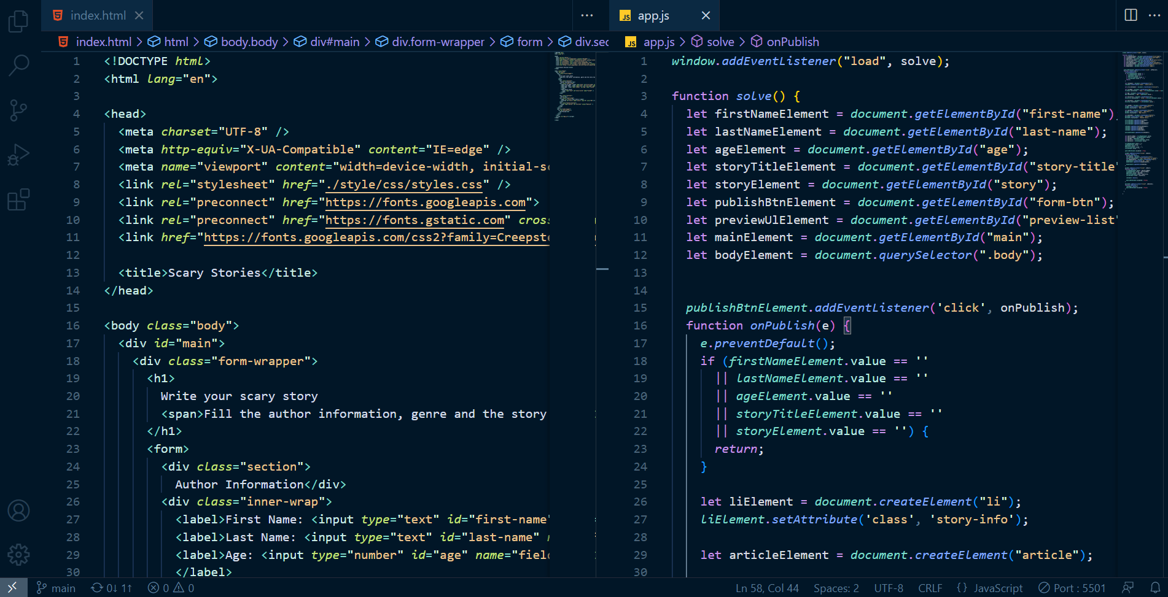

Step 2: Creating Branches
Senior makes 2 more branches (qa and staging) that are clones of the main branch.
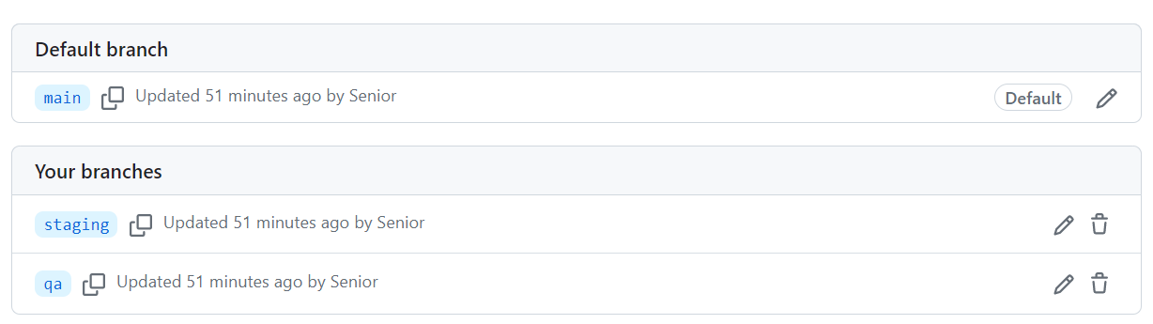

Step 3: Creating a Branch Protection Rule
Create a branch protection rule for committing to main branch, following the steps below:
- On GitHub.com, navigate to the main page of the repository.
- Under your repository name, click [Settings]. If you cannot see the [Settings] tab, select the […] dropdown menu, then click [Settings].
- In the "Code and automation" section of the sidebar, click [Branches].
- Next to "Branch protection rules", click [Add rule].
- Under "Branch name pattern", type the branch name or pattern you want to protect.
- Optionally, enable required pull requests.
- For more information see here: https://docs.github.com/en/repositories/configuring-branches-and-merges-in-your-repository/managing-protected-branches/managing-a-branch-protection-rule

Step 4: Creating GitHub Projects Board
Senior makes the GitHub Projects board "Scary Stories" and adds 3 issues ("Change Background",
"Add genre field", "Add field icons") in the "Pending" section. After that they move them to the "Sprint TODO" section.
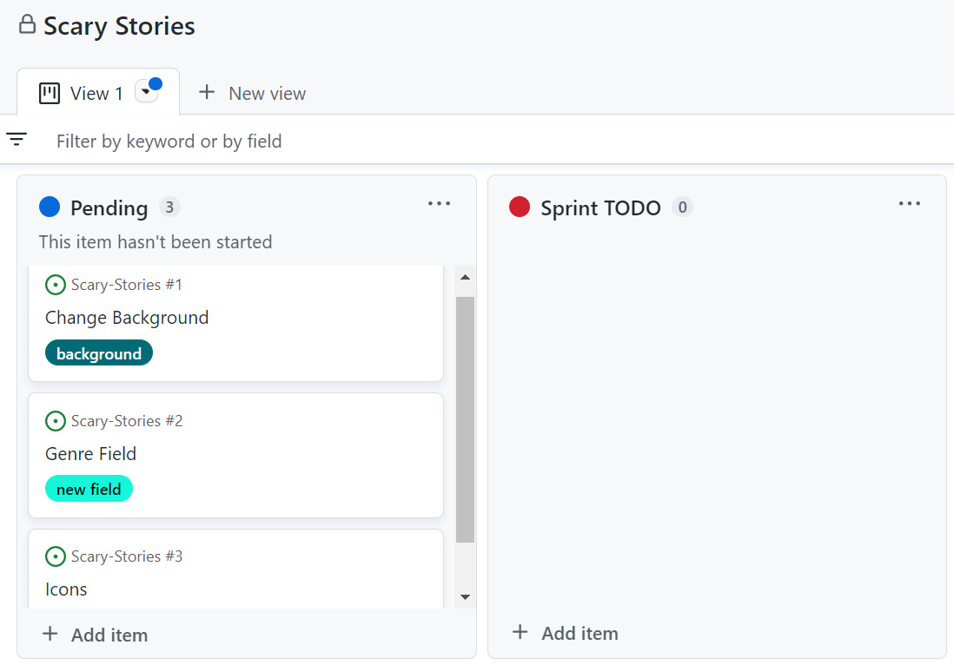
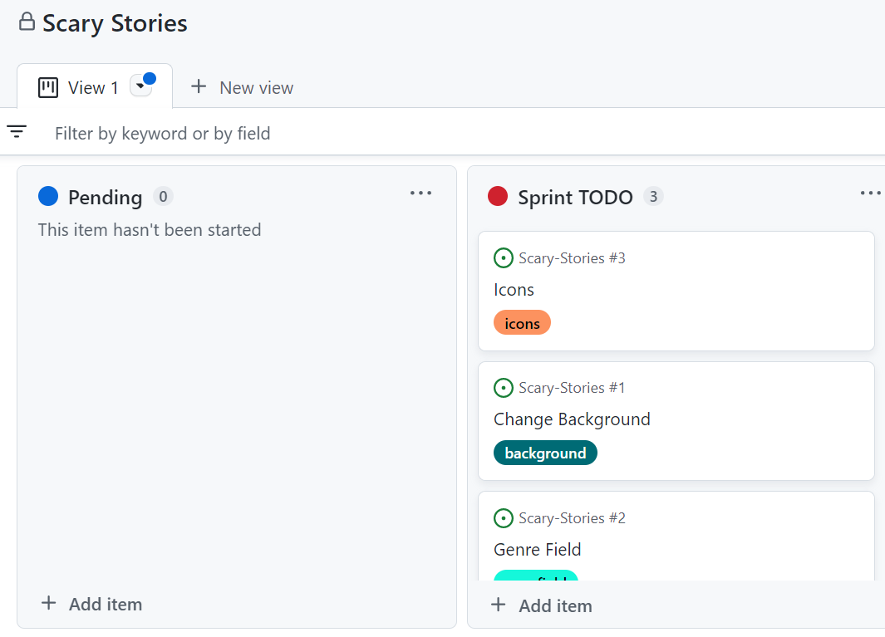

Step 5: Deploying site
Senior deploys site from the staging branch to the staging environment on Render.com.
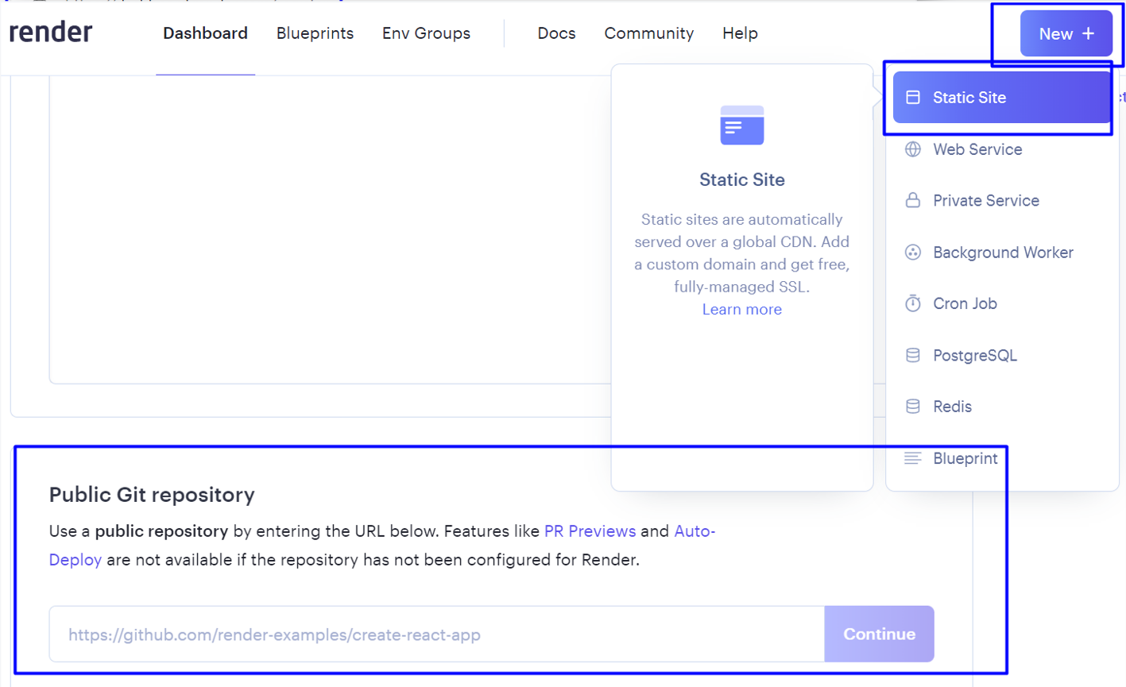
Senior conducts a code review when a pull request is created to the staging branch.
At the end, Senior merges the staging to the main branch.
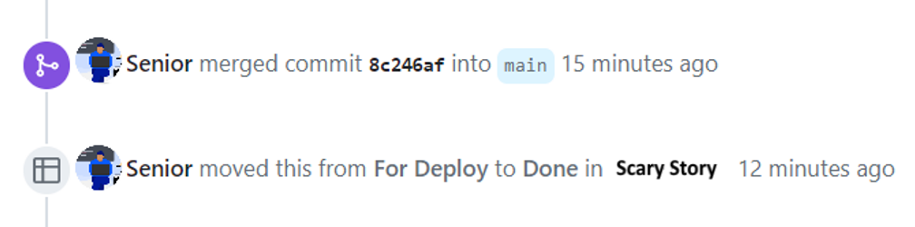
Senior deploy site from the main branch to the production environment on Render.com.

QA

Step 1: Deploying QA Branch
QA deploys site from the qa branch to the QA environment on Render.com (first time, then it will be automated)


Step 2: QA Environment Check
QA looks QA environment to see if changes are done correctly.
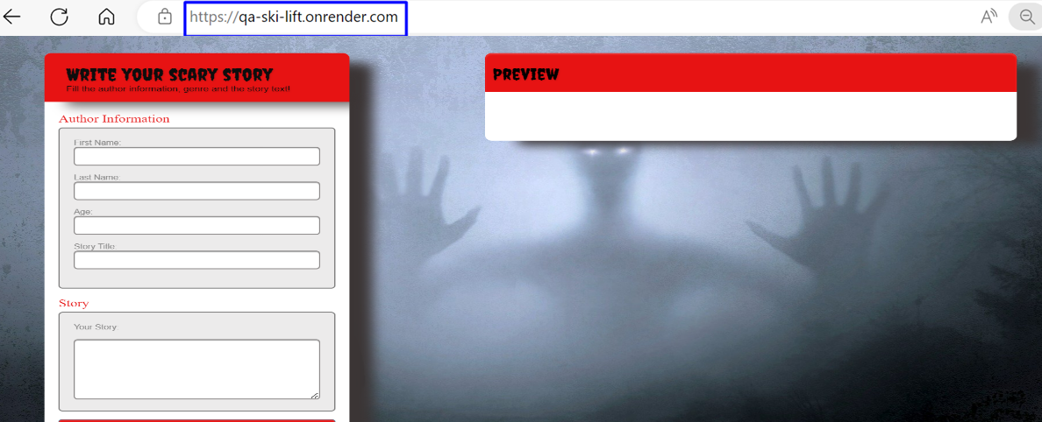
If something does not pass, return the issue to "In Progress"
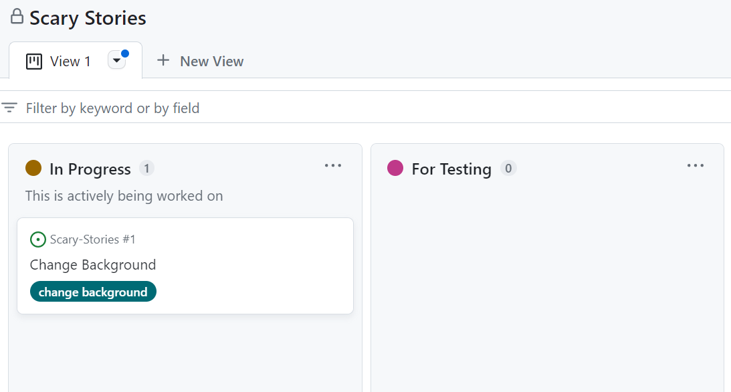

Junior

Step 1: Taking the Tasks
Junior takes the task "Change Background" from the "Sprint TODO" section and transfers it to "In Progress".
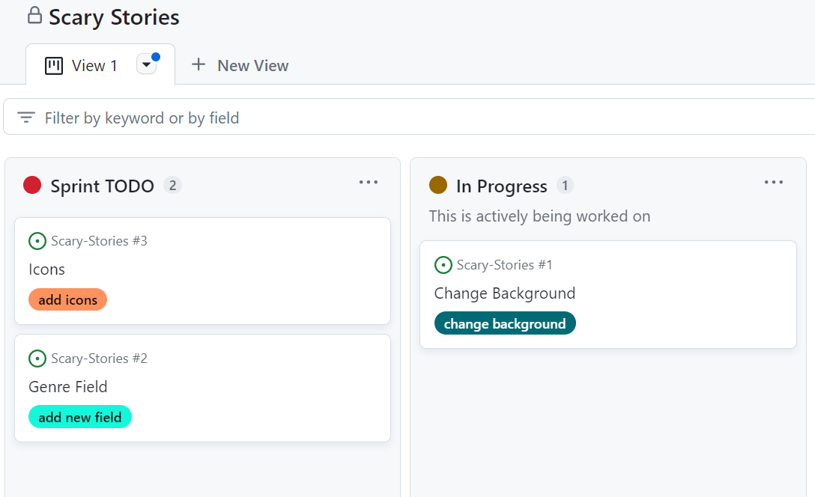

Step 2: Creating a Branch
Then they should create a new branch – change-background.
After that they implement the functionality for current issue.
- Change Background Issue
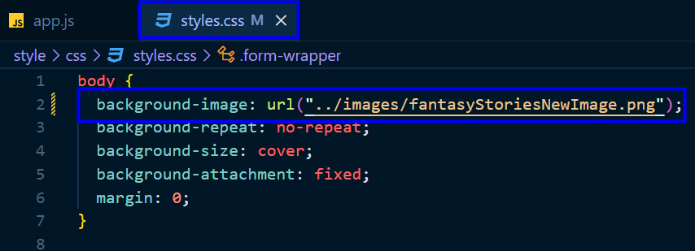
Junior commits into background branch and after that move the "Change Background" issue from "In Progress" to "For Testing" column.
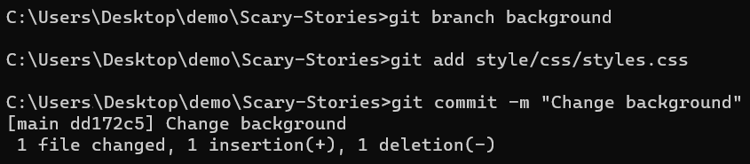
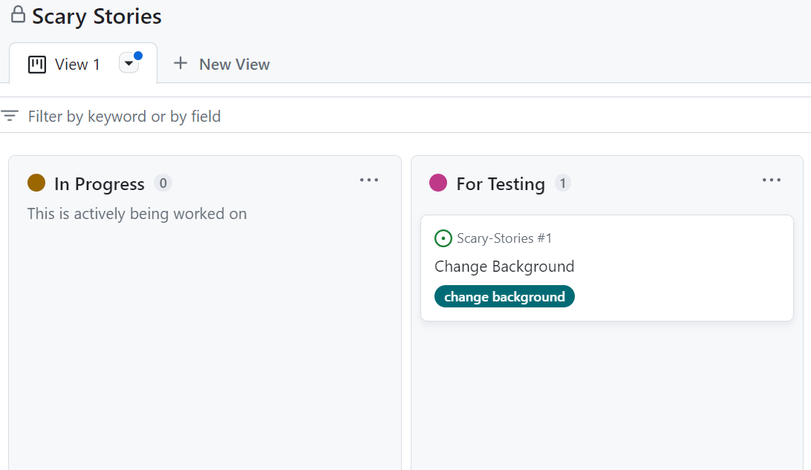

Step 3: Open a Pull Request
Then, if the issue is "Verified", merge its feature branch to the staging branch with a pull request. 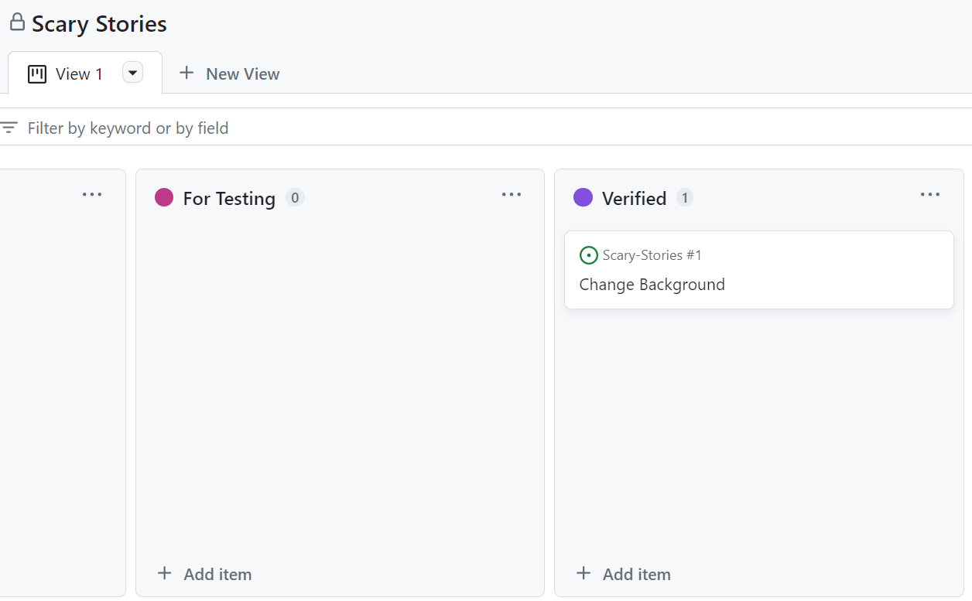
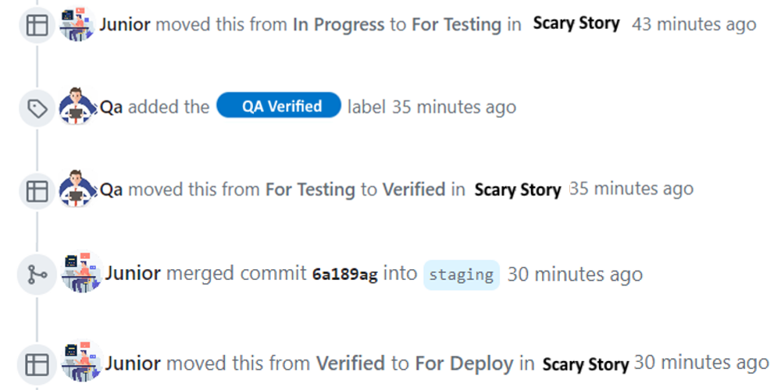
Junior does the same for the rest of the tasks ("Add genre field", "Add field icons").
- The necessary changes for "Add field icons" are:
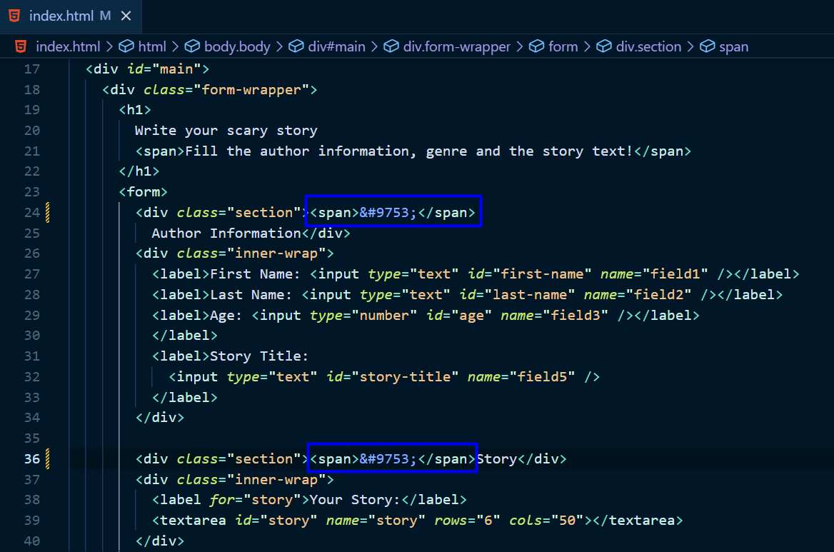
- The necessary changes for "Add genre field" are:
